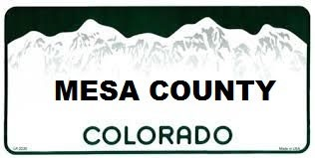
CREDIT CARD PAYMENT AUTHORIZATION
970-244-1664

PLATE #/VIN #:_________________________________
KCW PASS (STATE PARKS PASS): Y_______ N_______

Card Number:
___ ___ ___ ___ ___ ___ ___ ___ ___ ___ ___ ___ ___ ___ ___ ___

Expire Date: ______/______ CVV ________ (3 or 4 digit code on back of card)

Card Holder Name: _________________________________________________

Billing Address:
_________________________________________________________________

_________________________________________________________________

Phone Number: (_____)________________________

E-mail: ______________________________________

I am requesting payment of my full registration and/or title fees. Please accept my signature of authorization for the charge. The charge will show on my statement as CO Motor Vehicle Services. Credit cards will have an additional processing fee of less than 3%.

Signature: ______________________________ Date: ___________________

****PLEASE ATTACH PROOF OF INSURANCE****

**COUNTY USE ONLY** DATE OF TRANSACTION:__________________
E-Check Authorization Form

PLATE #/VIN #:_________________________________
KCW PASS (STATE PARKS PASS): Y_______ N_______
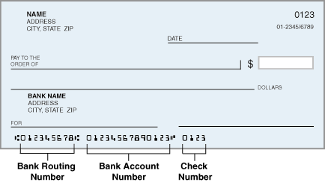
Account Type (please mark one)
□Personal Checking Account
□Personal Savings Account
□Business Checking Account
□Business Savings Account

Routing Number ________________________________
Account Number________________________________
Check Number: NOT NEEDED
Account Holder Name _____________________________
Billing Address:
_____________________________________________
_____________________________________________
Phone Number (____)___________________
E-mail _______________________________

I am requesting payment of my full registration and/or title fees. Please accept my signature of authorization for the charge. The charge will show on my statement as CO Motor Vehicle Services. There will be a $1.00 processing fee for all e-checks.

Signature: ______________________________ Date: ___________________

****PLEASE ATTACH PROOF OF INSURANCE****

**COUNTY USE ONLY** DATE OF TRANSACTION:__________________

